**Assignment 1 Test Case**

# Register/Login Test case: Validating User Input.

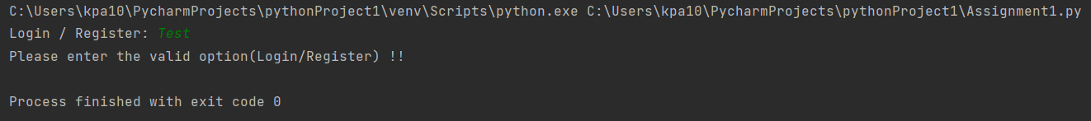

# Register Test case 1: email/username should have "@" and followed by "."

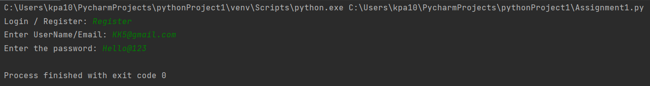

# Register Test case 2: it should not be like @gmail.com

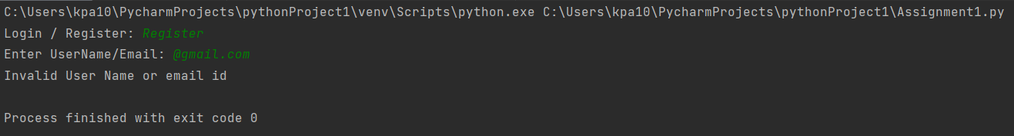

# Register Test case 3: There should not be any "." immediate next to "@"

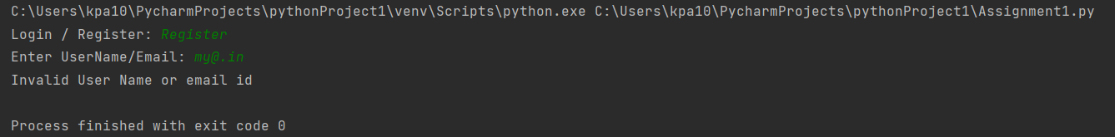

# Register Test case 4: Should not start with special characters and numbers

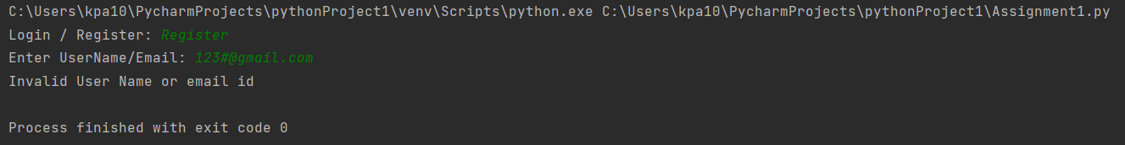

# Register Test case 5: password (5 < password length > 16)

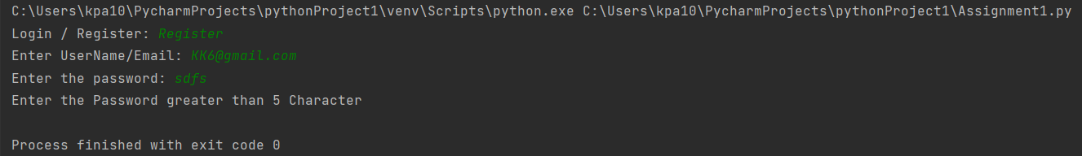

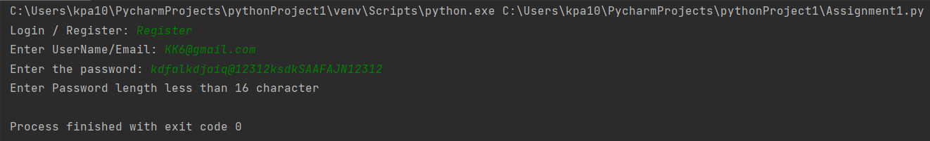

# Register Test case 5: Password must have minimum one special character, one digit, one uppercase, one lowercase character.

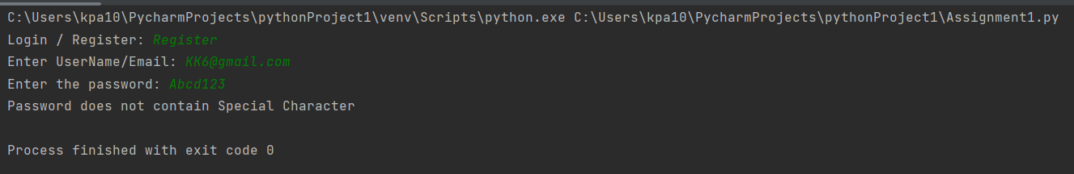

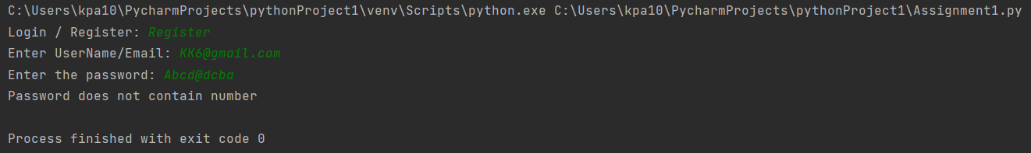

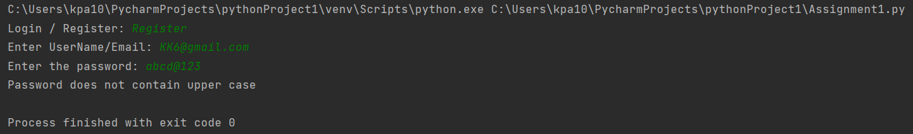

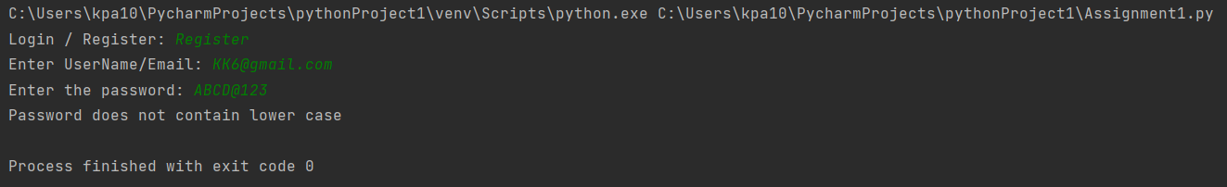

# Register Test case 6: Successful login and written to file.

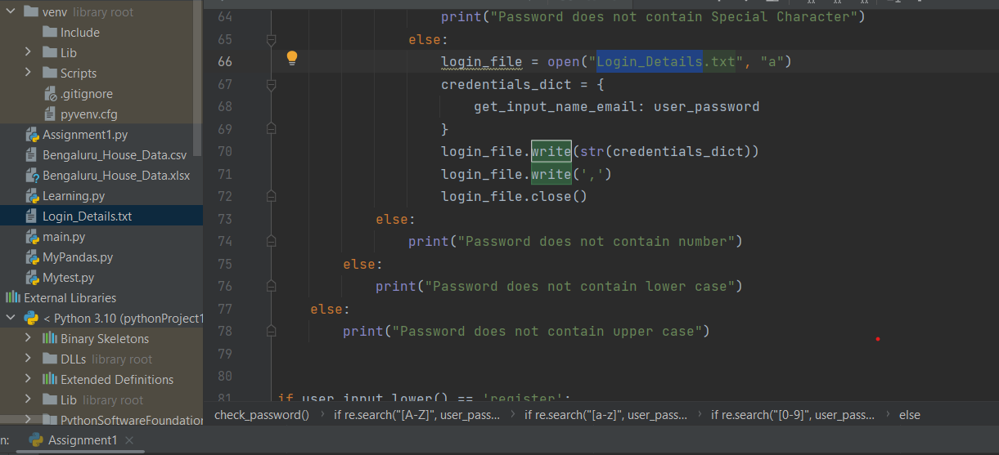

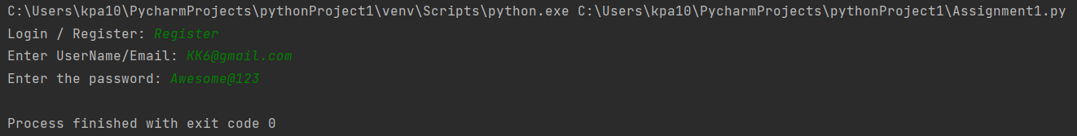

# Login Test case 1: Successful login for existing email id

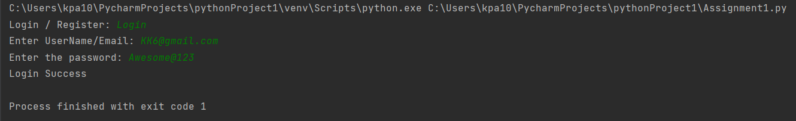

# Login Test case 2: Unsuccessful login for non-existing email id

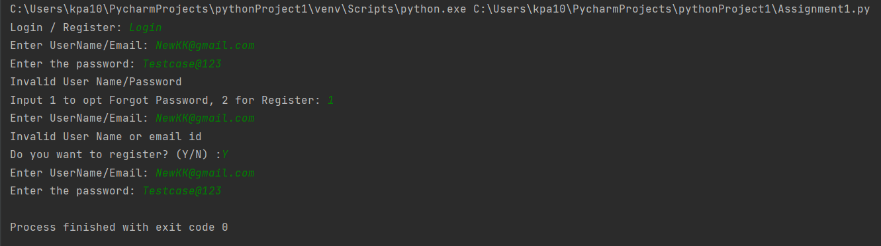

# Login Test case 3: Unsuccessful login for existing email id to fetch old password

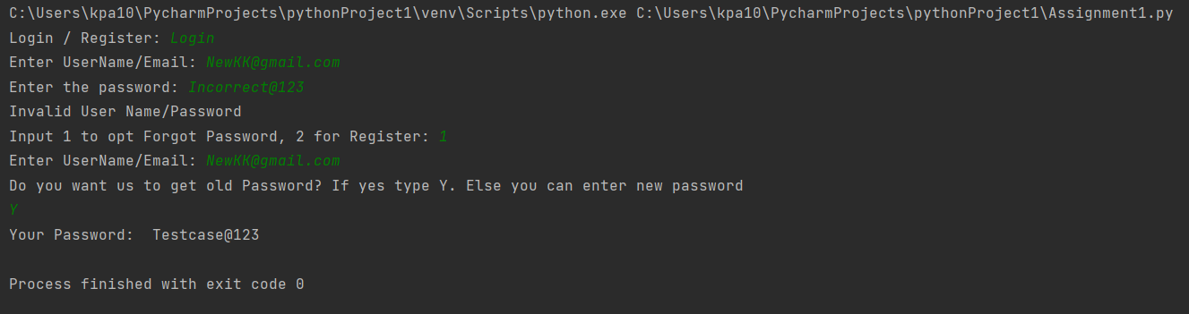

# Login Test case 4: Unsuccessful login for existing email id to set new password

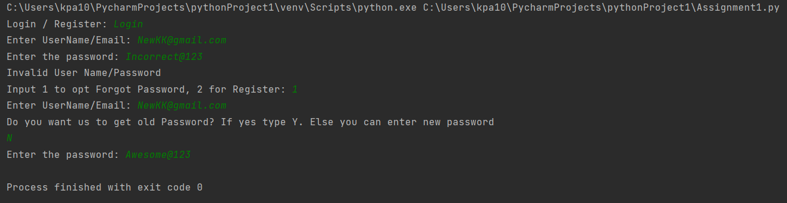

# Login Test case 5: Unsuccessful login for Non existing email id

